Name : Arka Haldi

Date : 9/9/2020

UID : 2018130014

CEL 51, DCCN, Monsoon 2020

Lab 4: Prototyping a Network



**Objective:**

Prototype a network using Packet Tracer

**Background**

A client has requested that you set up a simple network with two PCs connected to a switch. Verify that the hardware, along with the given configurations, meet the requirements of the client.

**Step 1: Set up the network topology**

1. Add two PCs and a Cisco 2950T switch
2. Using straight-through cables, connect **PC0** to interface **Fa0/1** on **Switch0** and **PC1** to interface **Fa0/2** on **Switch0**.

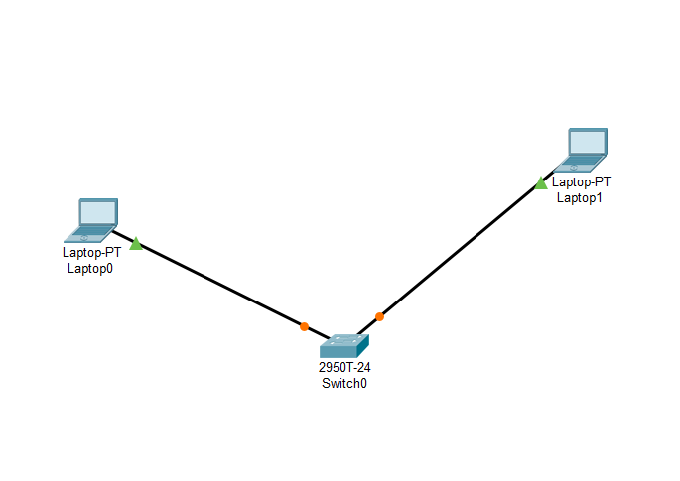

1. Configure PC0 using the **Config** tab in the PC0 configuration window:
   1. IP address: 192.168.10.10
   2. Subnet Mask 255.255.255.0
2. Configure PC1 using the **Config** tab in the PC1 configuration window
   1. IP address: 192.168.10.11
   2. Subnet Mask 255.255.255.0

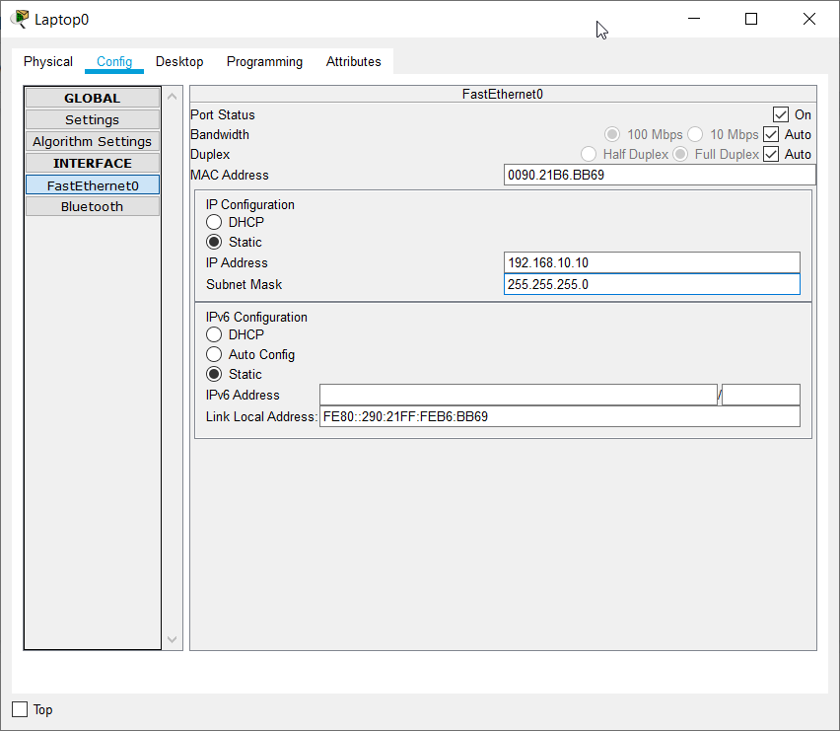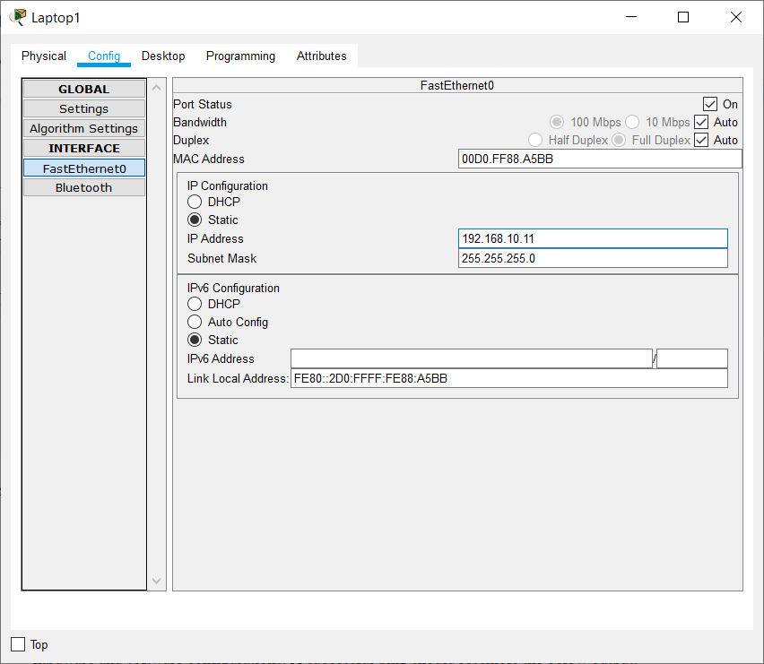

**Step 2: Test connectivity from PC0 to PC1**

1. Use the **ping** command to test connectivity.
   1. Click PC0.
   2. Choose the **Desktop** tab.
   3. Choose **Command Prompt**.
   4. Type: **ping 192.168.10.11** and press *enter*.
2. A successful **ping** indicates the network was configured correctly and the prototype validates the hardware and software configurations. A successful ping should resemble the below output:

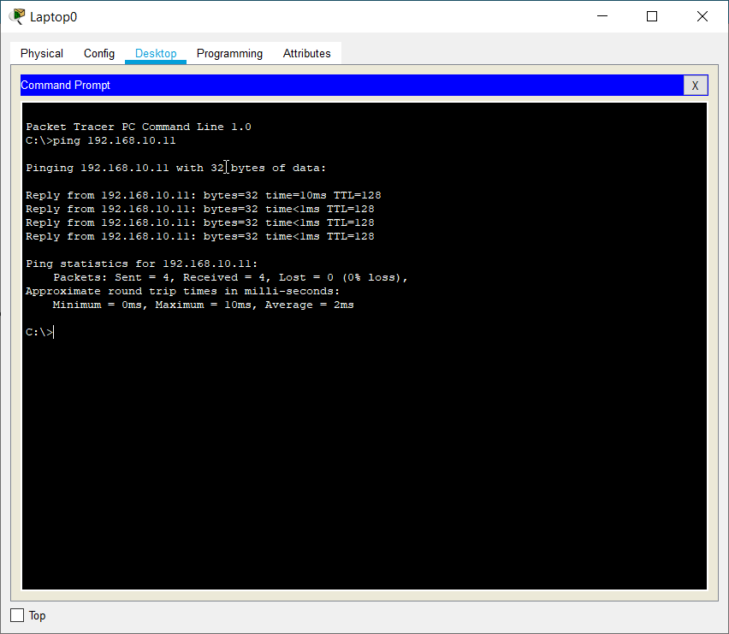

1. Close the configuration window.
2. Click the **Check Results** button at the bottom of the instruction window to check your work..

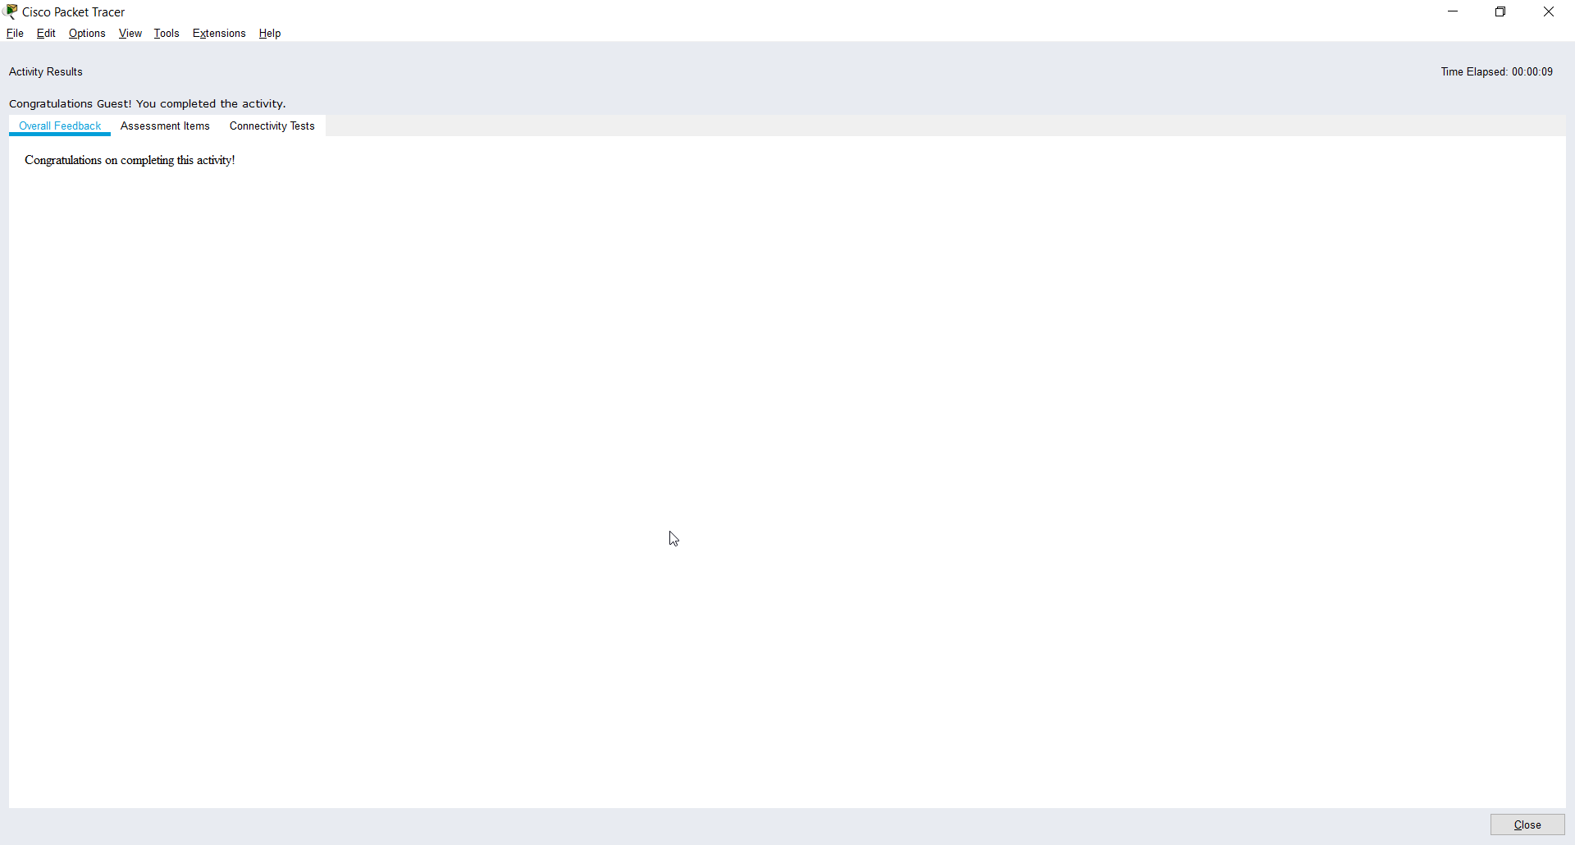

**Theory:**

1. **Network Switch**

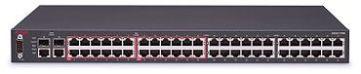

A network switch (also called switching hub, bridging hub, and by the [IEEE](https://en.wikipedia.org/wiki/IEEE) MAC bridge)[[1]](https://en.wikipedia.org/wiki/Network_switch#cite_note-1) is [networking hardware](https://en.wikipedia.org/wiki/Networking_hardware) that connects devices on a [computer network](https://en.wikipedia.org/wiki/Computer_network) by using [packet switching](https://en.wikipedia.org/wiki/Packet_switching) to receive and forward data to the destination device.

A network switch is a multiport [network bridge](https://en.wikipedia.org/wiki/Network_bridge) that uses [MAC addresses](https://en.wikipedia.org/wiki/MAC_address) to forward data at the [data link layer](https://en.wikipedia.org/wiki/Data_link_layer) (layer 2) of the [OSI model](https://en.wikipedia.org/wiki/OSI_model). Some switches can also forward data at the [network layer](https://en.wikipedia.org/wiki/Network_layer) (layer 3) by additionally incorporating [routing](https://en.wikipedia.org/wiki/Routing) functionality. Such switches are commonly known as layer-3 switches or [multilayer switches](https://en.wikipedia.org/wiki/Multilayer_switch).[[2]](https://en.wikipedia.org/wiki/Network_switch#cite_note-layer3-2)

[[Source]](https://en.wikipedia.org/wiki/Network_switch)

1. **Router**

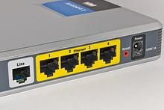

A router[[a]](https://en.wikipedia.org/wiki/Router_(computing)#cite_note-2) is a [networking device](https://en.wikipedia.org/wiki/Networking_device) that forwards [data packets](https://en.wikipedia.org/wiki/Data_packet) between [computer networks](https://en.wikipedia.org/wiki/Computer_network). Routers perform the traffic directing functions on the [Internet](https://en.wikipedia.org/wiki/Internet). Data sent through the internet, such as a [web page](https://en.wikipedia.org/wiki/Web_page) or [email](https://en.wikipedia.org/wiki/Email), is in the form of data packets. A packet is typically [forwarded](https://en.wikipedia.org/wiki/Packet_forwarding) from one router to another router through the networks that constitute an [internetwork](https://en.wikipedia.org/wiki/Internetwork) (e.g. the Internet) until it reaches its destination [node](https://en.wikipedia.org/wiki/Node_(networking)).[[2]](https://en.wikipedia.org/wiki/Router_(computing)#cite_note-3)

A router is connected to two or more data lines from different [IP networks](https://en.wikipedia.org/wiki/IP_network).[[b]](https://en.wikipedia.org/wiki/Router_(computing)#cite_note-4) When a data packet comes in on one of the lines, the router reads the [network address](https://en.wikipedia.org/wiki/Network_address) information in the packet header to determine the ultimate destination. Then, using information in its [routing table](https://en.wikipedia.org/wiki/Routing_table) or [routing policy](https://en.wikipedia.org/wiki/Routing_policy), it directs the packet to the next network on its journey.

[[Source]](https://en.wikipedia.org/wiki/Router_(computing))

CEL51, DCCN, Monsoon 2020

Lab 4.1: Basic configuration - hostname, motd banner, passwd etc



**Objective:**

This lab will test your ability to configure basic settings such as hostname, motd banner, encrypted passwords, and terminal options on a Packet Tracer 6.2 simulated Cisco Catalyst switch.

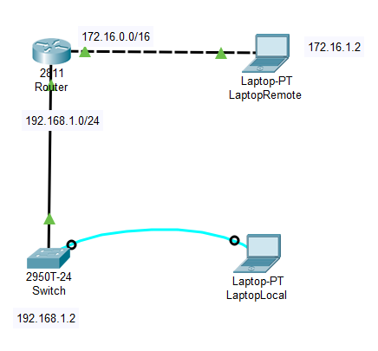

* Above is the configuration used in this experiment1 , with port IP at 0/0, and 0/1 as 172.16.1.1, and 192.168.1.1 respectively

**Initial Setup**

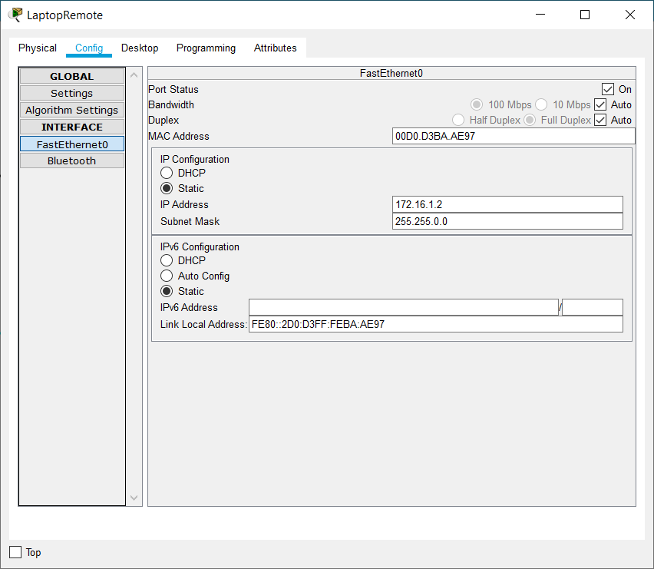

* Set IP address of Remote Laptop as 172.16.1.2,

belonging to the same subnet as the Router Gateway IP that it’s connected to.

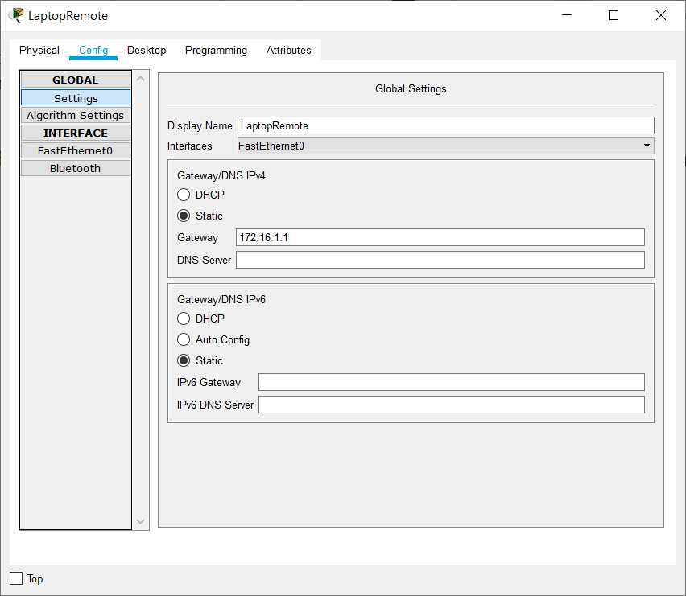

* Set the default gateway to 172.16.1.1, this port IP has to be configured at the Router port.

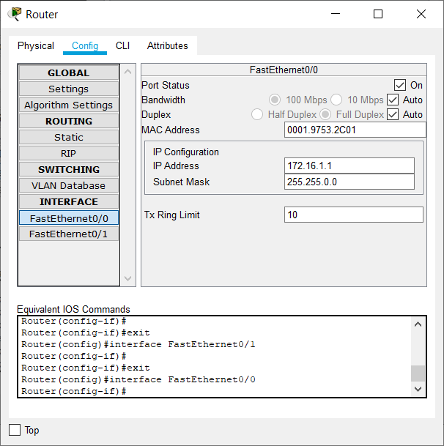

* Enter the IP Gateway entered in the Remote Laptop as the FastEthernet port ID, with the same Subnet Mask as that of the Remote Laptop

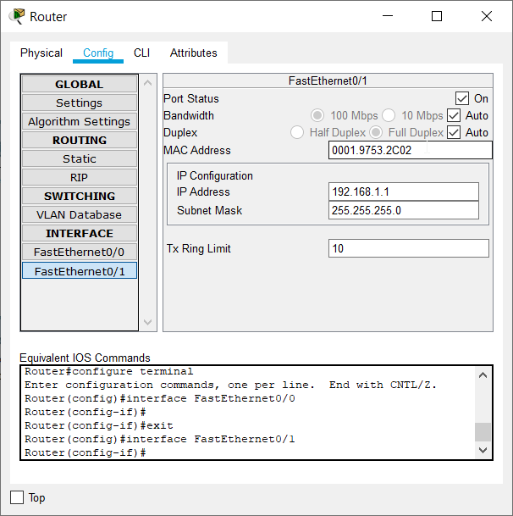

* Set the IP Gateway to be entered into the Router, as the port IP at the FastEthernet1 of the Router

1. Use the local laptop to connect to the switch console.

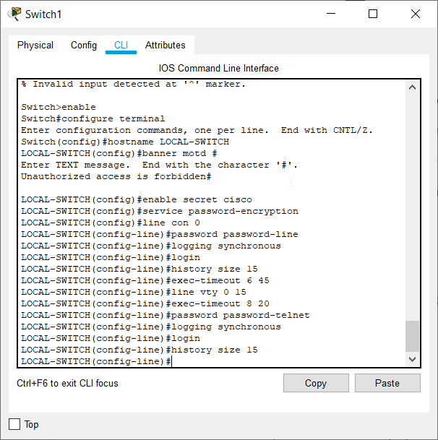

* All of the configuration to the Switch to set encryption, make logging in synchronous, adding MOTD, and switching encryption on, etc are all done in the above lines

2. Configure Switch hostname as LOCAL-SWITCH

3. Configure the message of the day as "Unauthorized access is forbidden"

* Here as we observe, we enter the configuration mode of the Router CLI, and configure the hostname as the new name, and Attach a MOTD to the Switch. 

4. Configure the password for privileged mode access as "cisco". The password must be md5 encrypted  
5. Configure password encryption on the switch using the global configuration command  
6. Configure CONSOLE access with the following settings :  
- Login enabled  
- Password : password-line  
- History size : 15 commands  
- Timeout : 6'45''  
- Synchronous logging   
  
6. Configure TELNET access with the following settings :  
- Login enabled  
- Password : password-telnet  
- History size : 15 commands  
- Timeout : 8'20''  
- Synchronous logging 



7. Configure the IP address of the switch as 192.168.1.2/24 and it's default gateway IP (192.168.1.1).

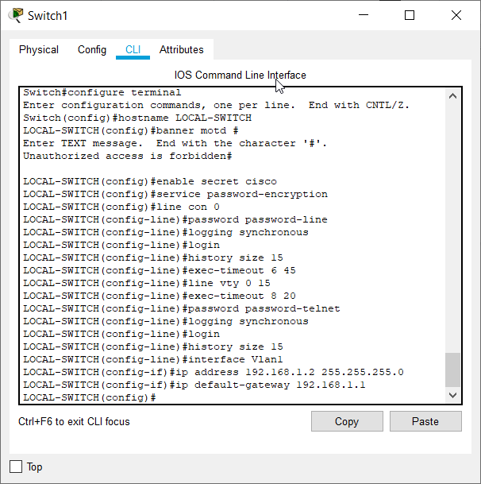

8. Test telnet connectivity from the Remote Laptop using the telnet client.

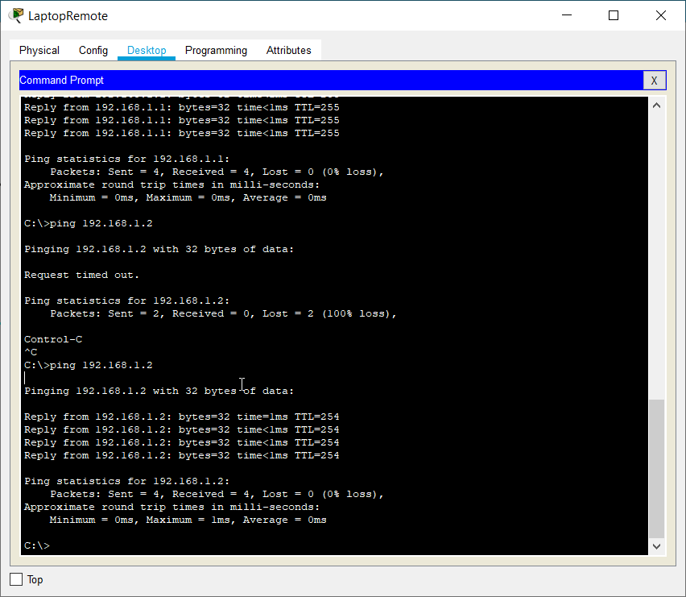

* Successfully pinged 192.168.1.2, i.e the Switch. Next we check the telnet client

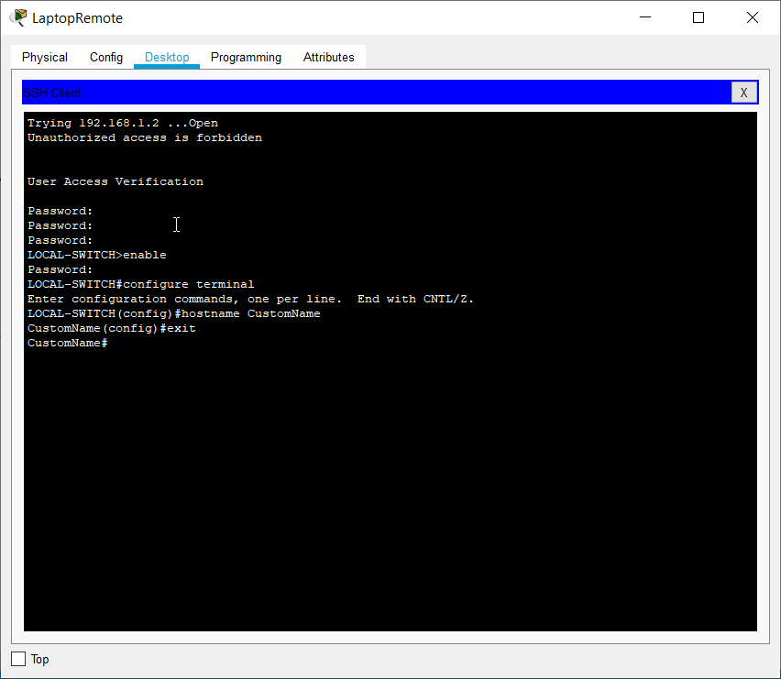

* Used Telnet to rename the switch from Remote Laptop, using the CLI of Switch.
* Hostname changed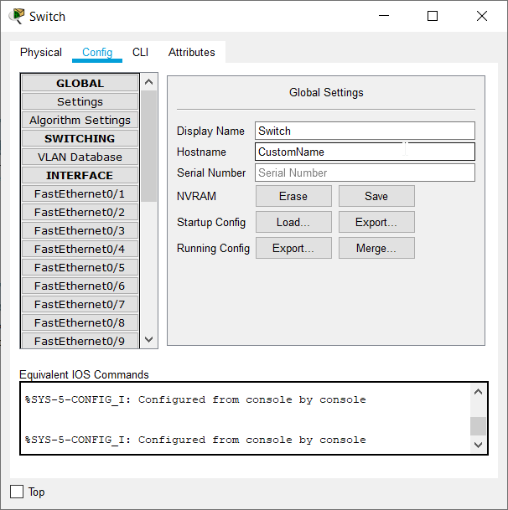

**Conclusion:**

* Hence, we have successfully demonstrated telnet utility using a simple Router, Switch topology.
* We learnt how to make the IP connections, how to assigned IP addresses to ports, about IP Gateways, how to debug a network topology, about subnet masks, and Network IDs , and also about the reality of Networking as a whole.